|  |  |
| --- | --- |
| Course – Section | Computer Networks (CS3001 - Fall 2023) – (BDS-7B) |
| Assignment Number | 04 |
| Total Marks | 55 Marks |
| Assigning Date | November 24 2023 |
| Due Date/Time | November 27, 2023 |
| Submission | Submit hand-written hardcopy in class and soft form on classroom as well. |
| Submission Guidelines | * *Please do the work by yourself, this is an individual assignment.* * *Plagiarism cases will be dealt with strictly.* * *Read questions and marks distribution carefully and write precise answers, avoiding wordy stories.* * *Make assumptions where needed but state them clearly in your answer.* * ***Q2, Q3, Q5 and Q6 are COMPULSORY while rest are for your practice.*** |

**Question 1:** An organisation is granted a block with one of the IP addresses as 150.100.80.0/22. The administrator wants to create 4 subnets with the following requirements: 1st subnet needs at least 300 IP addresses, 2nd subnet needs at least 200 IP addresses, 3rd subnet needs at least 100 IP addresses while 4th subnet needs at least 120 IP addresses. The following are required from you:

1. Write the subnet mask for each subnet.
2. Write the first and last IP address in each subnet (Network and Broadcast addresses).
3. Write the number of addresses in each subnet.
4. Write the range of valid host addresses in each subnet.

# [2+2+2+2 = 8 Marks]

**Question 2:** Differentiate between forwarding and routing. Write 3 points for each. Also state a brief packet transfer scenario where these come into play. **[5 Marks]**

**Question 3:** Draw labelled IPv4 datagram. Also describe each of the following in 3 to 4 lines:

1. What is TTL and how it is determined.
2. What is the significance of Header checksum and how it is calculated.
3. What is Fragment Offset?
4. What is the significance of the Upper-layer-Protocols portion of the IPv4 header? Why was it eliminated from the IPv6 header?

# [6+4 = 10 Marks]

|  |  |
| --- | --- |
| **Question 4:** Apply Link State and Distance Vector algorithms on the following graph. Do not omit steps from the solution. Assume node **A** as the source node.  **[5+5 = 10 Marks]** |  |

**Question 5: Write whether you agree or disagree with the following prompts.** Give reason for your choice in in 2 to 3 lines as well:

1. IPv4 to IPv6 transition is possible by tunnelling. Draw a diagram to show how if you agree.
2. DHCP is a plug and play protocol.
3. Dynamic routing is more advantageous than static routing. Also write 2 pros of the one you think is more advantageous.
4. NAT is not a use case of gateway routers.

# [1+1+2+2 = 6 Marks]

**Question 6:** For the following scenario where Routers R1 and R2 with interfaces 0, 1, 2, 3, 4, and 5, 6 respectively, constitute the network. Use IP Address Aggregation (Route Summarization) and fill the entries in the following table. (Default entries are pre-filled)

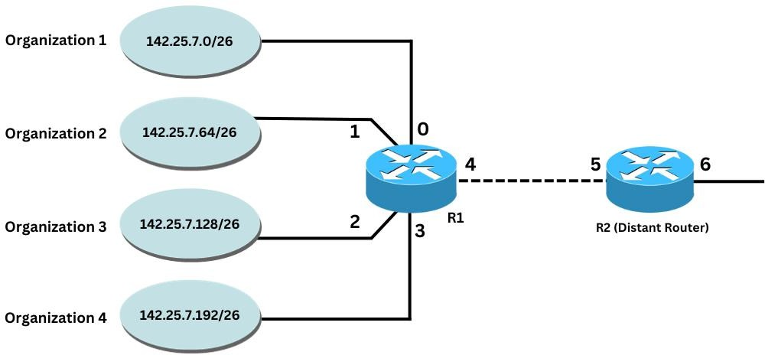

# [2.5+2.5 = 5 Marks]

|  |  |  |  |  |
| --- | --- | --- | --- | --- |
| Routing Table for R1 | |  | Routing Table for R2 | |
| IP Address Range with Prefix | Interface | IP Address Range with Prefix | Interface |
| 0.0.0.0/0 | 4 | 0.0.0.0/0 | 6 |
|  |  |  |  |
|  |  |  |  |
|  |  |  |  |
|  |  |  |  |

**Question 7:** A datagram of 4,000 bytes arrives at a router and must be forwarded to a link with an MTU of 1,5XX bytes (where XX are the last 2 digits of your roll number) . The datagram is stamped with the identification number XXX (where XXX are the last 3 digits of your roll number). Explicitly state into how many fragments the datagram is divided. Fill the following table with the relevant characteristics of the fragments:

# [6 Marks]

|  |  |  |  |  |
| --- | --- | --- | --- | --- |
| Fragment Serial Number | Size in Bytes | ID | Offset (Also give reasoning for your value) | Value of the Flag (1 or 0) |
| Make rows according to the number of fragments | | | | |

**Question 8:** Consider the OpenFlow network shown in the following figure. Suppose that the desired forwarding behaviour for datagrams arriving from host h3 or h4 at s2 is as follows:

* any datagrams arriving from host h3 and destined for h1, h2, h5 or h6 should be forwarded in an anti-clockwise direction in the network
* any datagrams arriving from host h4 and destined for h1, h2, h5 or h6 should be forwarded in a clockwise direction in the network

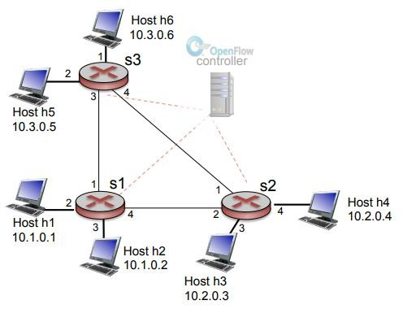

Specify the flow table entries in s2 that implement this forwarding behaviour.

**[5 Marks]**